M³AAWG Meeting – Atlanta, Georgia
October 19-22, 2015

GENERAL HOTEL INFORMATION:
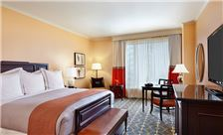
InterContinental Buckhead Atlanta
3315 Peachtree Rd NE
Atlanta, Georgia 30326
Phone: 404.946.9000

Fax: 404.946.9001

Room Rates:
Standard Room (Deluxe) $199.00 Single / Double

This room rate is non commissionable to travel agents.

Reservations:
The M³AAWG Rate will be offered 3 DAYS before and after the meeting based on availability. The M³AAWG negotiated room rate is guaranteed until Friday, September 25, 2015. After September 25, please contact the hotel directly to determine availability.

The individuals can make reservations directly to the Hotel by:
Phone: +1 404.946.9000
Toll Free Calling: +1 800.496.7621
Online: http://www.intercontinental.com/redirect?path=rates&brandCode=ic&localeCode=en&regionCode=925&hotelCode=ATLBH&checkInDate=19&checkInMonthYear=092015&checkOutDate=23&checkOutMonthYear=092015&numberOfAdults=1&numberOfRooms=1&_PMID=99801505&GPC=L6B

Check In Time: 15:00
Check Out Time: 12:00

Cancellation Policy:
Credit cards are needed to guarantee reservations. Reservations cancelled 24 hours prior to arrival will receive a full refund of their deposit. Any reservation cancelled after 24 hours prior to arrival or no shows will forfeit 1 night’s room and tax revenue.

Business Center:
Location: Lobby Floor
Hours of Operation: 24 hours

Fitness Center:
Location: 2nd Floor
Hours of Operation: 24 hours
Cost: Complimentary for hotel guests

High Speed Internet Access in Sleeping Rooms:
Complimentary if booked in the M³AAWG group room block.
Standard Wired/Wireless Fee: $10.00 USD

MEETING INFORMATION:

M³AAWG Office:
Location: Willard
Office Hours: 8:00 – 17:00

Registration:
Location: Pre-Function Area
Hours: 8:00 – 18:00

Meeting-At-A-Glance
Monday, October 19 Training & Chair’s Meeting
Tuesday, October 20 General Session & Breakouts
Wednesday, October 21 General Session & Breakouts
Thursday, October 22 General Session & Breakouts

TRAVEL INFORMATION:

Hartsfield Jackson International Airport (ATL)
Distance from hotel: 19 miles / 30.58 km
Drive time: 35 minutes

Driving Directions: Take I-75/I-85 North to I-85 North to GA 400 North. Take Exit #2 for Lenox Rd/Buckhead. Exit Right off the ramp, go to the second traffic light and make a right on to Peachtree Rd. InterContinental Buckhead is 5 lights down on the Left.

-Taxi Charge: $22.00 (one way):
-Super Shuttle: $20.50 (one way), $ 35.00 (round trip)
Book a lift at: http://groups.supershuttle.com/m3aawg35thgeneralmeeting.html.
-Private Sedan Service: $95.83, (one way) including tax and gratuity. Call Concierge Desk: 404-946-9177
-MARTA Train Charge (one way): $2.50 plus a $1.00 charge for Breeze card.
Time by train: 45 Minutes

Train Directions:
From the airport take the red line North- depart the train at Buckhead N7 & locate signs directing to the InterContinental and go to furthest exit to reach street level, turn left and the hotel is 2 blocks down on the left.
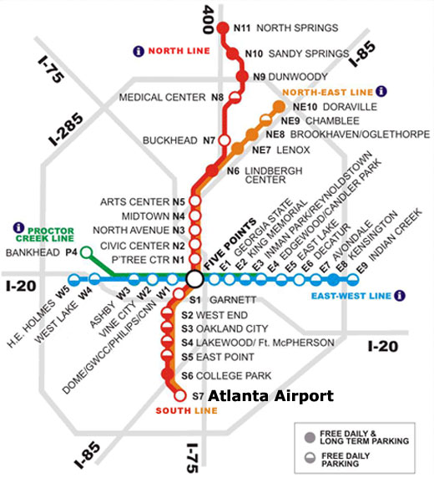

Airline Discount:
Delta Airlines
Online: www.delta.com
When booking online select Meeting Event Code and enter the code NMM26 in the box provided on the Search Flight page.
Call Delta Meeting Network Reservations: 800-328-1111
Reference Delta Code: NMM26
Please note that a Direct Ticketing Charge will apply for booking by phone.

United Airlines
Online: www.united.com
Enter Offer Code ZTXJ811408 in the Offer Code box when searching for your flights.
Call United Reservations Meeting Desk: 800-426-1122
Reference Z Code: ZTXJ and Agreement Code: 811408
Please note there is a $25.00 per ticket service fee collected when tickets are issued through the United Meetings Reservations Desk.

Visas
A citizen of a foreign country who wishes to enter the United States must first obtain a visa, either a nonimmigrant visa for temporary stay, or an immigrant visa for permanent residence. The visa allows a foreign citizen, to travel to the United States port-of entry and request permission of the U.S. immigration inspector to enter the U.S. The "visitor" visa is a nonimmigrant visa for persons desiring to enter the United States temporarily for business (B-1), for pleasure or medical treatment (B-2), or combination of both (B-1/B-2) purposes.

Please visit US State Department to determine if you need to obtain a visa: http://travel.state.gov/visa/temp/types/types_1265.html

DESTINATION INFORMATION:

Atlanta, Georgia:

Originally built as the terminus of the Western & Atlantic Railroad, Atlanta remains a hub for transportation (with the world’s busiest airport), industry (with the headquarters for Coca-Cola), art (with treasures on display at the High Museum of Art), and natural wonders (with the world’s largest aquarium). The city’s half million residents enjoy a mix of old-fashioned Southern charm, offbeat artistic funkiness, chic luxury shopping, superb dining, and major attractions.

Known as “the city too busy to hate”, Atlanta has become the best example of the New South, a fast-paced modern city proud of its heritage. Transplanted Northerners and those from elsewhere account for more than half the population, and they have undeniably affected the mood of the city, as well as the mix of accents of its people. Since the 1980’s Atlanta has seen spirited growth in its Asian- and Latin- American communities. The newcomers’ restaurants, shops, and institutions have become part of the city’s texture.

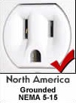
Currency: $ USD

Voltage: 110V

Language: English

Time Zone: Eastern Standard Time zone (-5 GMT)

Tipping: 15-20%, Bellmen, Doormen, and Room Service will expect a tip for their services. You are not expected to tip in fast-food restaurants, cinemas, or gas stations.

Weather Conditions:
Average High: 71°F, 22°C
Average Low: 50° F, 11°C

Dining:
This is a city known for its food; many a trip to Atlanta is planned around meals in its barbecue shacks, upscale diners, and chic urban eateries. Traditional Southern fare-including Cajun and creole, country-style and plantation cuisine, coastal and mountain dishes – thrives, as do Asian fusion, traditional Ethiopian, creative vegan, and mouth-scorching Indian food. Catch the flavor of the South at breakfast and lunch in diners and other modest establishments that serve only these meals.

Local Attractions:

- The Georgia Aquarium: World’s largest aquarium with more than 10 million gallons of water.
- Atlanta Botanical Garden: Occupies 30 acres inside Piedmont Park.
- National Center for Civil and Human Rights: Museum offers visitors a multisensory immersion into both the U.S. civil rights movement and global human rights efforts.
- World of Coca Cola: Features more than 1,200 artifacts never before displayed to the public.
- CNN Center: Studio Tour is a behind-the-scenes glimpse of the control room, newsrooms, and broadcast studios.
- Piedmont Park: A popular destination since the late 19th century, many retreat to the park’s great lawn for picnics.
- Sweet Auburn Curb Market: True public market where vendors sell flowers, fruits, vegetables, etc. and local favorites such as Bell Street Burritos and Grindhouse Killer Burgers.
- Martin Luther King Jr. National Historic Site and Birth Home: Queen Anne-style residence where Martin Luther King Jr. was born and raised.
- Ebenezer Baptist Church: Known as the spiritual center of the civil rights movement.
- Centennial Olympic Park: Twenty-one acre swath of green was the central venue for the 1996 Summer Olympics.
- Fox Theatre: One of a dwindling number of vintage palaces in the nation, built in 1929.
- Atlanta History Center: One of Southeast’s largest history museums that focuses on life in Atlanta during and after the Civil War.
- Stone Mountain Park: Home to the world’s largest piece of exposed granite.
- High Museum of Art: With its renowned collection of classic and contemporary art the museum has grown from its origins in a stately home on Peachtree Street to become the leading art museum in the southeastern United States.

