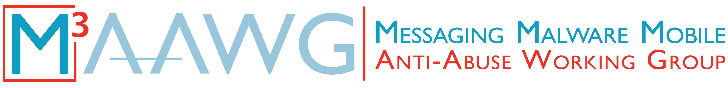

Messaging, Malware and Mobile Anti-Abuse Working Group

M³AAWG Objectionable Content Takedown Template

(Checklist Only)
September 2022

The reference URL for the full document: https://www.m3aawg.org/ObjectionableContentTakedownTemplate

Process Checklist
This template is only a guide; adjust it to the organization’s specific needs and situation.

Please ensure each step below has been taken. Note details requested such as names, date and times.

Step Taken | Date/Time Completed | Details/Sign-off
Step 1: Triage/Prioritize
Perform an assessment of the objectionable content to determine or validate the scope of the infraction. |  | (Include how the content was vetted, by whom, and the rationale for the assessment.)
Material is CSAM.
Invoke separate CSAM handling procedures and exit.
Meets the threshold for objectionable content.
Go to Step 2: Action Required
Does not meet the threshold.
No further action required.
Go to Step 6: Case Closeout
Step 2: Action Required
When required, consult with appropriate government entities to determine if alternative actions are required.
Alternative actions required.
Perform alternative actions and branch accordingly.
Determine who has response control. |  | (Determine whether in-house or client responsibility.)
In-house responsibility
Go to Step 3a: In-house Response Control
Client responsibility
Go to Step 3b: Client Response Control
Step 3a: In-house Response Control
Determine appropriate mitigation steps.
Initiate and execute mitigation steps.
Go to Step 6: Case Closeout
Step 3b: Client Response Control
Determine what is required to perform immediate blocking of the service/material prior to notifying the client.
Adequately notify the affected client of the issue and actions that have already been taken. |  | (Include who was notified and when.)
Notify customer account representatives. |  | (Include who was notified and when.)
Have all parties agreed on a mitigation action plan and timeframe. Plan should consider both regulatory and contractual requirements. |  | (Include details and timeframe.)
Obtain acknowledgement from the customer that remedial actions will be enforced (including potential termination of services) if mitigation steps are not completed within the agreed timeframe.
Step 4: Client Action
Client executes mitigation steps.
Client has successfully executed mitigation steps within the agreed timeframe.
Go to Step 6: Case Closeout
Client has not executed the mitigation steps within the agreed timeframe.
Go to Step 5: Remedial Action
Step 5: Remedial Action
Obtain approval from legal counsel for the execution of remedial action. |  | (Provide an approved date of remedy.)
Provide remedial action notice to the customer. |  | (Include who was notified and when.)
Execute remedial action (may include termination of service).
Go to Step 6: Case Closeout
Step 6: Case Closeout
Perform applicable post-takedown procedures. |  | (May include informing the reporting party of action taken.)
Close case.

_______________________

As with all documents that we publish, please check the M3AAWG website (www.m3aawg.org) for updates.

© 2022 Messaging, Malware and Mobile Anti-Abuse Working Group (M3AAWG) M3AAWG-139

